# Keyman Keyboard Usage Instructions

Please make sure that Keyman is already running in your machine. This can be seen my the small keyboard key-like icon in the taskbar.



In some cases, the icon could be hidden as shown below;

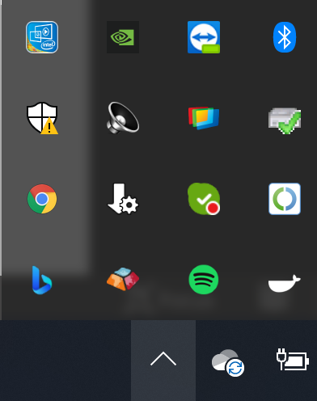

If you cannot see the icon, please start Keyman.

With Keyman running, you should be able to see the Tamil Extended keyboard by clicking on the language icon (that most probably says ENG).

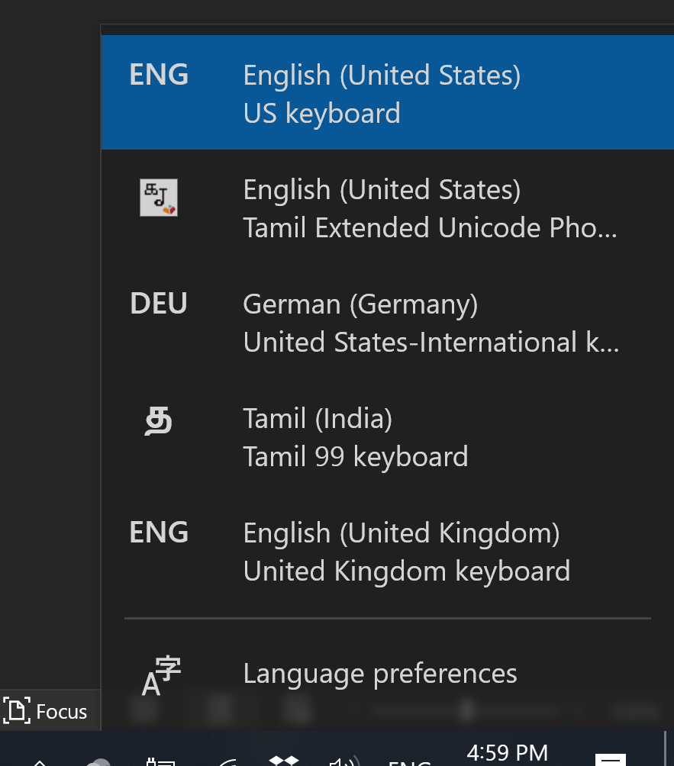

Open your favorite word processor and set the font as Agastya or Lopamudra.

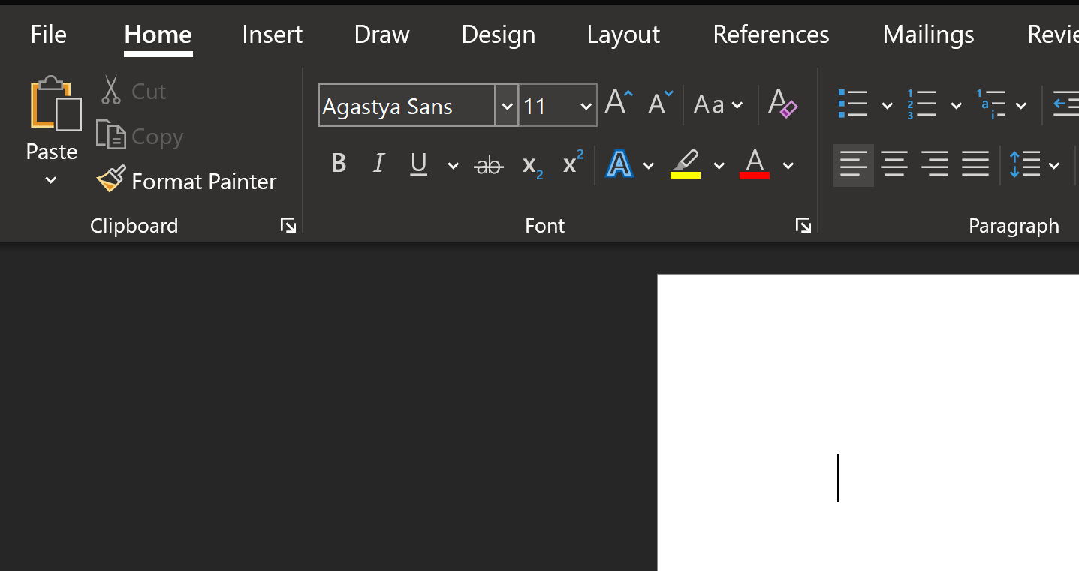

Using the language menu as shown above, set the Keyboard to “Tamil Extended Unicode Phonetic”. You can also invoke the language menu using windows key + space bar.



You can now compose text using the Tamil Extended script. Make sure the font is properly set as Agastya/Lopamudra.

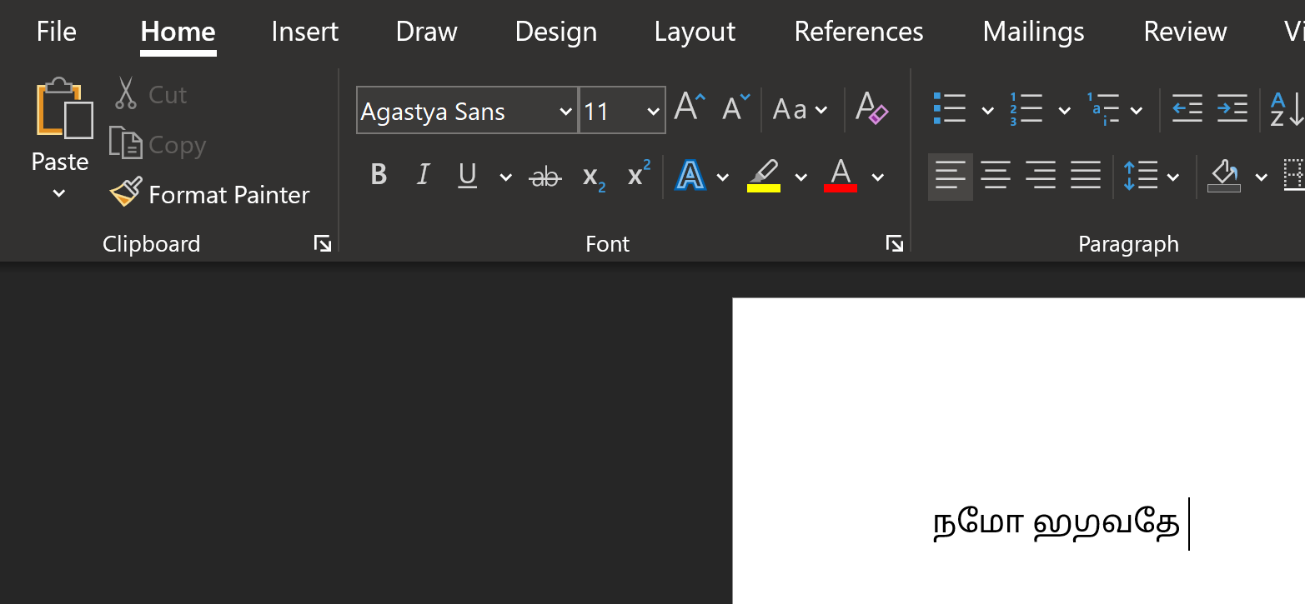

If the font switches back and the characters appear as Malayalam, reselect the text and assign the proper font again.

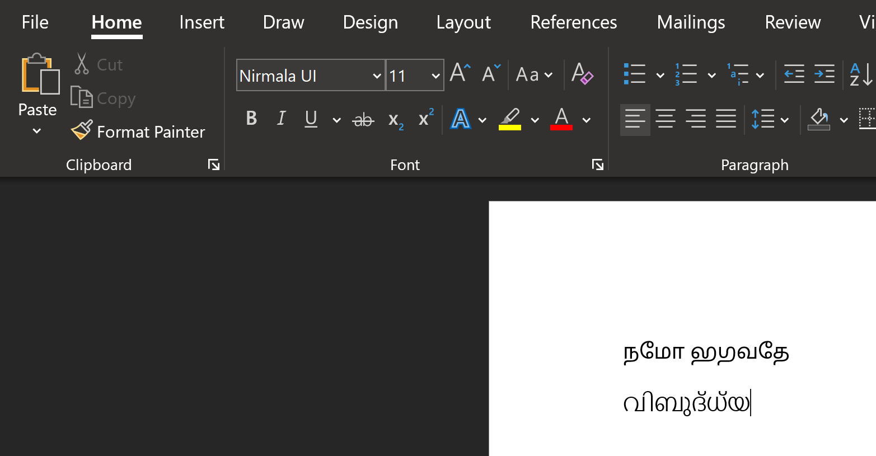

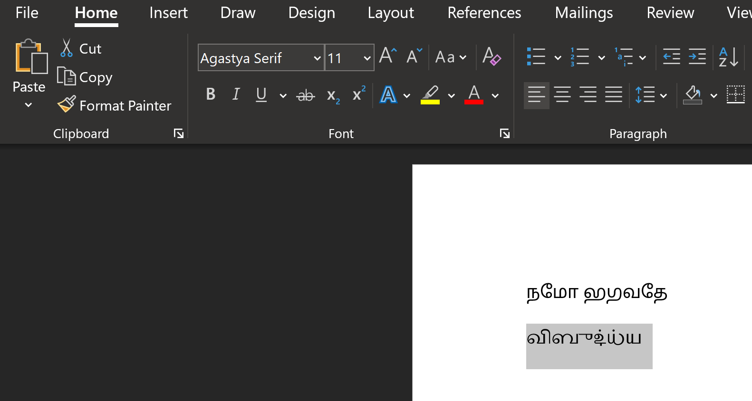

They keyboard mapping can be found under the start menu within the folder "Tamil Extended Unicode Phonetic".

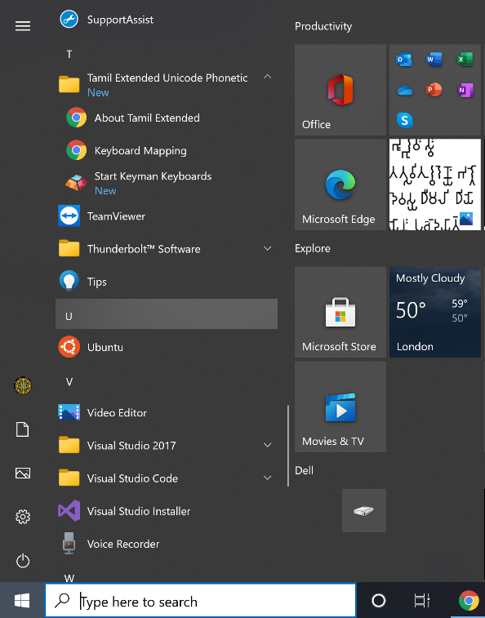

## Possible Issues

When creating a new document with word, the first syllable might appear as malformed. Just insert a blank space and start typing if that’s the case.

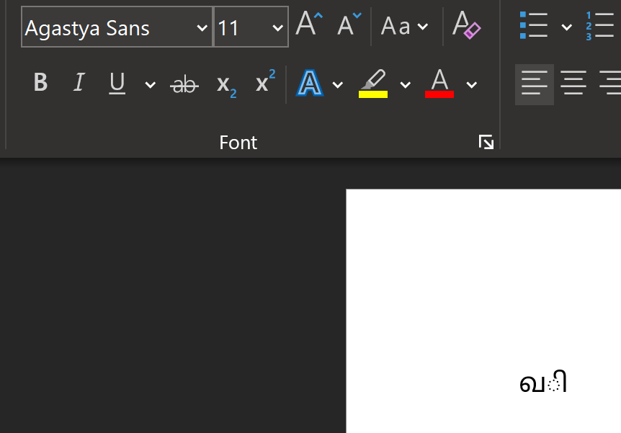

With Vedic Svaras, MS Word might switch the font to a Devanagari font. If that happens, reselect the text and set the font again to Agastya/Lopamudra.

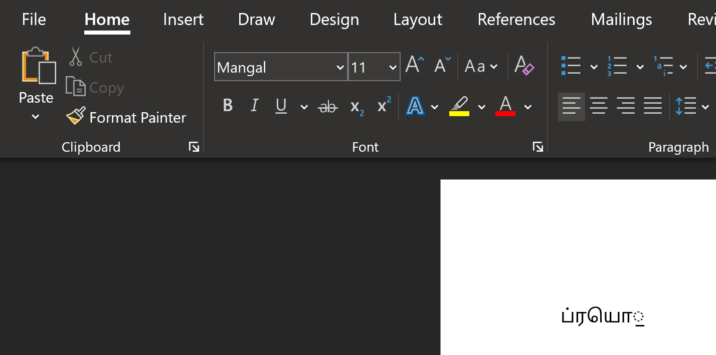

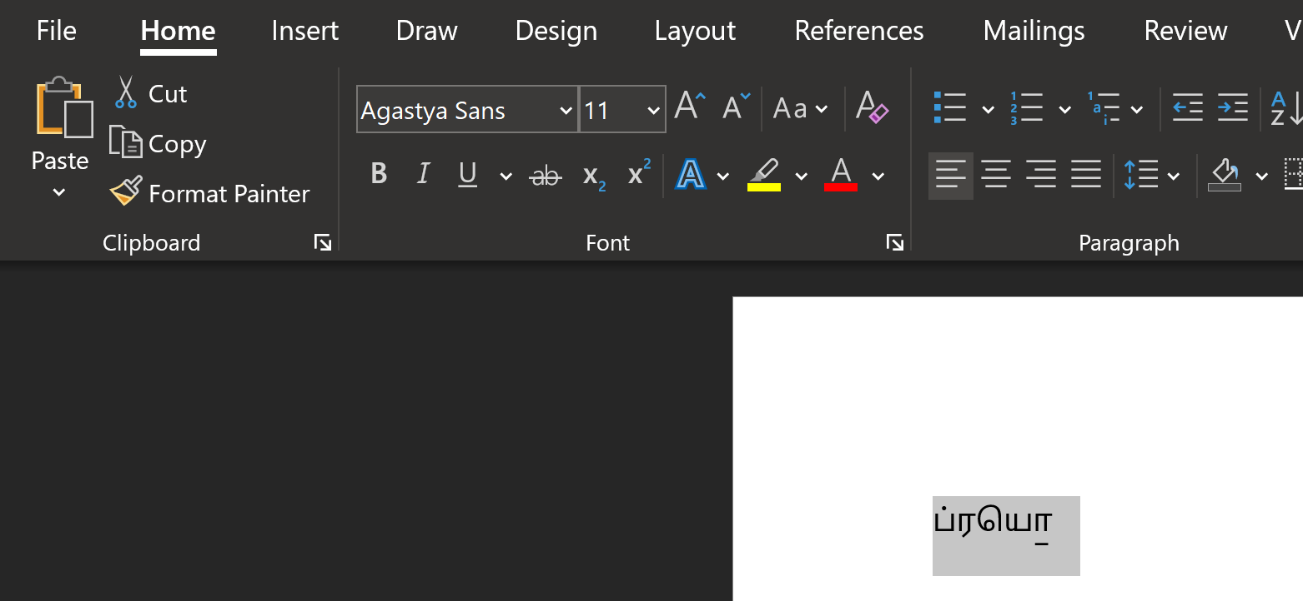

## Using Stylistic Sets

Agastya and Lopamudra come with stylistic sets to access variant forms of characters.

Stylistic Sets can be activated using Word’s advanced font features. Select the text and click on the advanced font settings.

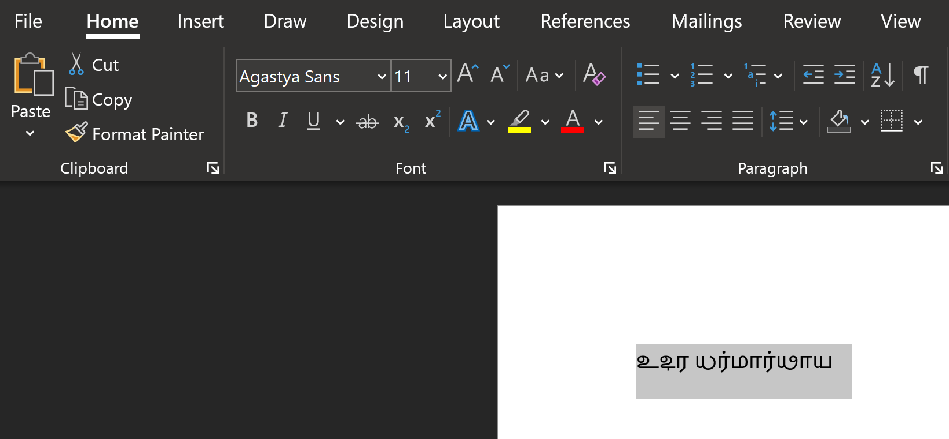

This will give you the following font menu.

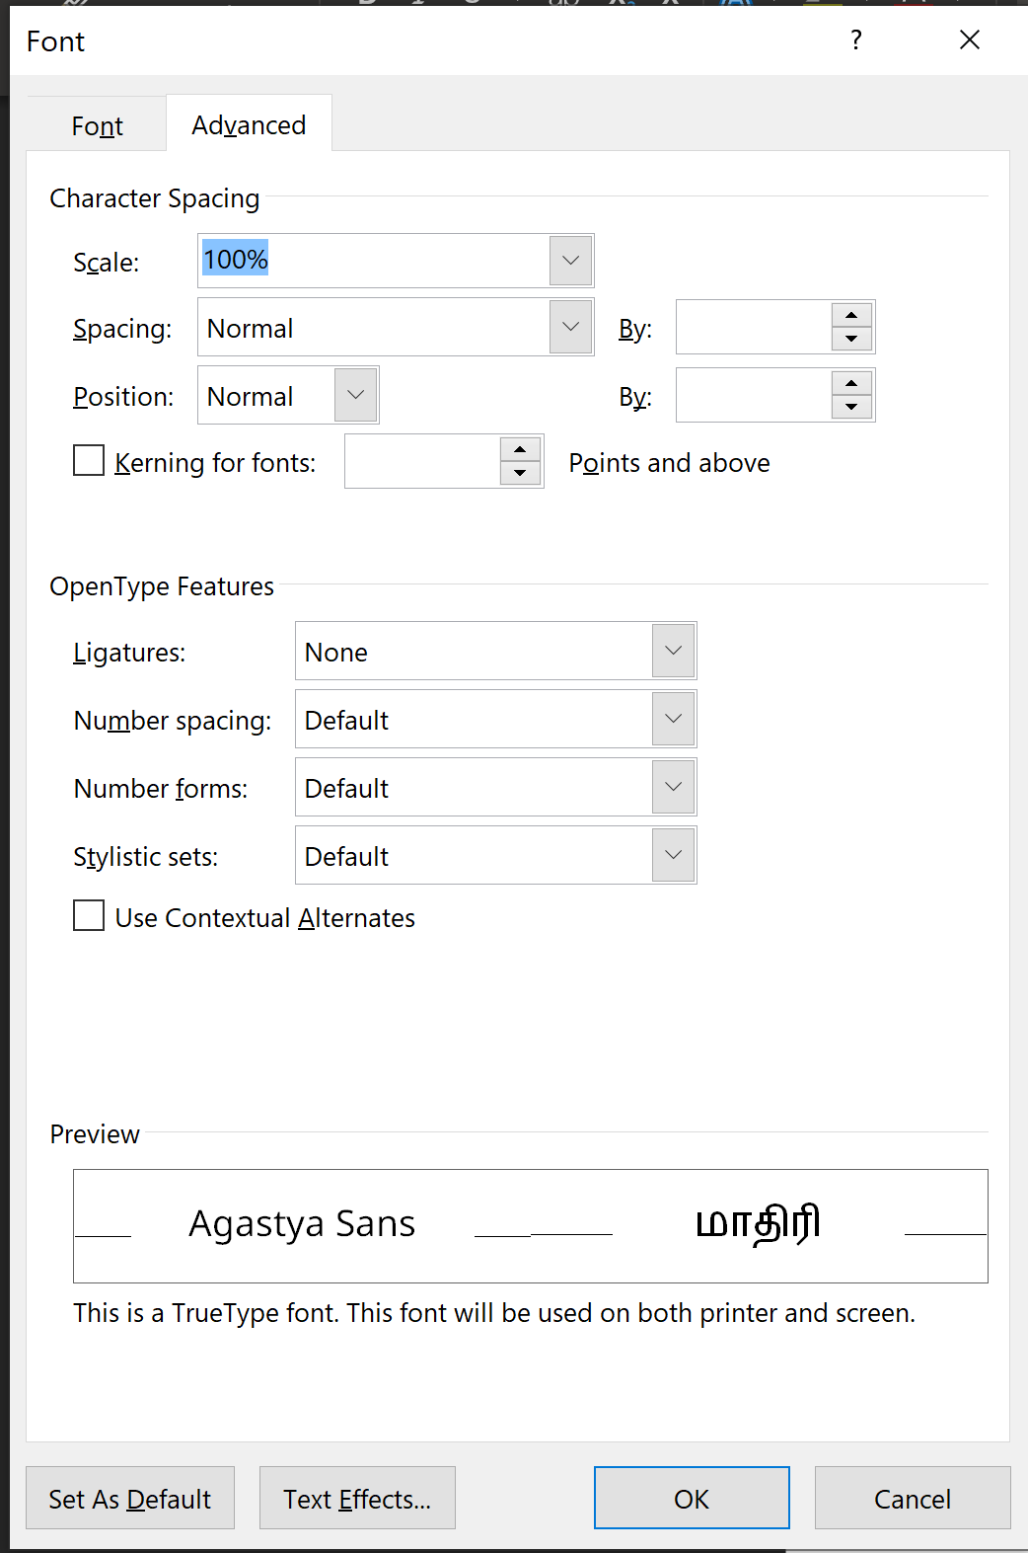

In the Stylistic sets section, select 1 or 2.

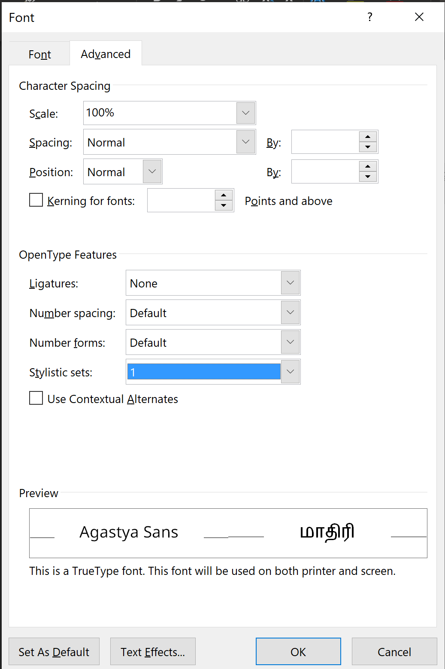

Click on OK and the Stylistic set is applied to the selected text.

